



Telephone: 059 8627226

E-mail: [principal.ballyadams@gmail.com](mailto:principal.ballyadams@gmail.com)

Office: [secretary.ballyadams@gmail.com](mailto:secretary.ballyadams@gmail.com)

Website: www.ballyadamsns.com

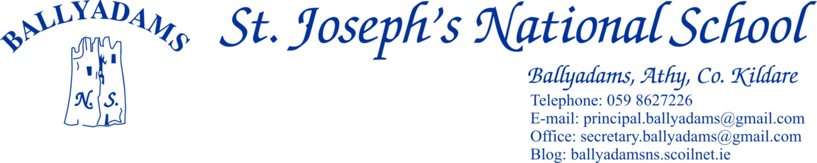

April 18th, 2018

***Newsletter***

**Parents’ Council**

Thank you to our Parents’ Council for organising the Easter Raffle once again this year. We got a wonderful response from you all and the money raised will go towards updating our school library.

**Internet Safety**

The Parents’ Council recently organised a talk from Sharon Hayden of the NPC (National Parents Council) on the topic of Internet Safety. The focus of the talk was around safe usage of internet applications and educating our children around appropriate behaviour online through looking at content, guidance, discussion and example. She encouraged setting clear rules based on age-related trust and responsibility and doing random checks on devices. Safety online is a huge concern given the range of internet applications that children use. Thank you to all who attended and helped supply the baked goods on the night.

Also, Community Garda Sergeant Steve Mulqueen recently visited 3rd-6th Classes to speak with the children on the topic of Internet Safety. The website [www.webwise.ie](http://www.webwise.ie) provides parents with free expert advice, explainers and how to guides. It is well worth exploring.

**Confirmation/Communion**

Congratulations to all those pupils in 5th and 6th class who were confirmed by Bishop Nulty on March 16th. I hope you all had a truly memorable day. Thank you to the rest of the pupils and staff who helped out on the day, and in particular Ms. Walsh and Ms. Holden’s choir who sang beautifully.

2nd Class continue to prepare for their First Holy Communion. The First Confessions take place today, April 18th at 2pm, followed by refreshments in the school hall for parents and children. Communion day is May 12th. We’d encourage parents and family members to play an active part in preparing the children for the sacraments.

**Book Fair**

Thank you to all those who contributed towards our book fair in March. The school will receive €465 worth of book vouchers in return.

**Pitch and Gear**

We have reopened the school pitch for 3rd Class – 6th Class pupils. However, they must wear football boots and spare tracksuit/shorts to play on the pitch. If we get a spell of dry weather in the coming week or two, we’ll allow the Infants and 1st/2nd Class on the grass with their runners and school tracksuits.

**Hurling/Camogie/Football**

Our boys and girls are currently taking part in their respective hurling/camogie competitions. Both groups are improving steadily and we wish them well in their remaining games. Our camogie team are at home to Clough tomorrow, while our boys are away to Gaelscoil Phortlaoise on Friday.

Football coaching with Sean Dempsey and Laois GAA coach/player Colm Begley will commence next Wednesday for boys and girls in 3rd – 6th Classes. Please ensure pupils have gear and gum shields.

**Active School**

Our Active School Committee are busily preparing for Active School’s Week next week (April 23rd – 27th). Please read the note sent home by our committee on Monday. We ask the children to wear their tracksuits each day. There will be activities and active homework throughout the week. On Monday, Ms Rowan and Ms Kirwan’s classes will visit Athy Tennis Club for a coaching session. Many thanks to Gary Geresford and Athy Tennis Club for providing the sessions and loan of rackets free of charge. We ask all pupils to bring in €2 each to help cover bus costs. On Thursday, there will be a whole school run, similar to the Santa Dash in December. If you are free to steward on the day, please ring Pam in the office. We hope to start at 1pm.

**Textaparent App**

There are still a significant percentage of parents yet to sign up to the TextaParent app. We’d encourage you all to do so if you’ve either an Apple or Android device. The more parents who download the app, the greater the saving for the school.

**TUSLA & Foster Care**

The Child and Family Agency TUSLA have written to local schools as part of their effort to recruit foster families to care for children of all ages, from birth to eighteen years and to recruit supported lodgings and after care families for children from fifteen to eighteen years old. There is currently a shortage of foster care families in the local area. Please visit the website [www.fostering.ie](http://www.fostering.ie) or call 0579370700 for further information.

**Making an Effective Transition to Second-Level: Workshop for Parents**

Laois Education Centre, Block Rd., Portlaoise are hosting an interactive seminar for parents of 5th and 6th Class pupils on Thursday May 3rd at 7pm. The objective is to support parents to develop resilient young people and prepare them to be ready to cope with change as they transition to second-level. Places are free but booking is essential. Contact Yvonne at 0578672402 to book a place.

**Morning Supervision/Staff Car Park**

I’ll remind you that morning supervision does not begin until 9:10am each morning. Therefore, your child should not be on the school premises before then.

The staff car park is for staff only. I’d ask you to please respect this Board of Management decision, which was made purely on safety reasons. The ***vast majority*** of parents and childminders use the church car park at dropping off/collection times and we thank you for your continued co-operation.

**Closures and half days**

**May Bank Holiday:** Closed Friday May 4th and Tuesday May 8th

**Referendum:** Closed Friday May 25th (school is being used as a polling station)

**June Bank Holiday**: Closed Friday June 1st and Tuesday June 5th

**June 13th:** Half-day closure for Child Protection in-service

Close for the **summer holidays** on Thursday June 28th 2018

**Please note the closure for the referendum on May 25th and the half day on June 13th.**

Mr. T. Fitzgerald

Principal