



Telephone: 059 8627226

E-mail: [principal.ballyadams@gmail.com](mailto:principal.ballyadams@gmail.com)

Office: [secretary.ballyadams@gmail.com](mailto:secretary.ballyadams@gmail.com)

Website: www.ballyadamsns.com

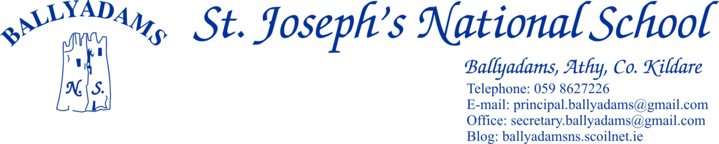

February 8th, 2018

***Newsletter***

**Parents’ Council**

Our Parents’ Council organised a very successful Cake Sale on Sunday last. There were all sorts of delightful cakes and treats on display. Many thanks to all those who baked, purchased and volunteered their time so freely.

Our annual Christmas Draw, our largest fundraiser of the year, was a huge success once more. On behalf of the Board of Management, staff and pupils, I’d like to say a sincere thank you to the Parents’ Council and the parent body in general for your continued support.

**Enrolment**

We are continuing to take enrolments for the school year 2018/19. Please contact Pam in the office for an enrolment form or for further details. Children must be at least four years old by September 1st 2018 in order to enrol. We ask you to encourage family, friends or neighbours to consider sending their children to our school if they are yet to decide.

**Confirmation/Communion**

2nd Class, 5th Class and 6th Class are busy preparing for their respective sacraments. The Confirmation Ceremony will take place on March 16th at 11am in Wolfhill Church. Bishop Denis Nulty will confirm the children on the day. The children will once again wear albs and details of rental costs will follow shortly. The Service of Light will take place in Wolfhill Church on March 8th at 7:30pm. 5th and 6th Class will also travel to Castletown on March 5th for their Confirmation Retreat.

The First Confessions will take place on April 18th at 2pm, followed by refreshments in the school hall for parents and children in 2nd Class. Communion day is May 12th. We’d encourage parents and family members to play an active part in preparing the children for the sacraments.

**Child Protection**

Following the publication of the new *‘Child Protection Procedures for Primary and Post-Primary Schools 2017’,* the Board of Management have adopted a new Child Safeguarding Statement. The staff and Parents’ Council were both consulted in the process. The ratified Child Safeguarding Statement and accompanying Risk Assessment will be published on the website in the coming days. The school will close at 12:30pm on Wednesday next, February 14th to allow for staff in-service on the new guidelines.

**Library/Appeal for boxes**

We are currently in the process of updating and restocking our school library. There are many books which are surplus to requirement and will be donated to charity. If you have any spare boxes you wish to donate/dispose of, we need them to store and transport the large number of surplus books.

**Uniforms and Tracksuits**

We ask the children to wear their full schools uniforms each day, except for designated PE days. The pitch remains closed, but we are hoping to reopen it in the coming weeks. Boots and spare tracksuits/shorts must be worn up the pitch at all times.

**Primary Science Fair**

The pupils in 4th and 5th Classes attended the RDS Primary Science Fair in Mary Immaculate College recently. Ms Kirwan’s class got to display their project, ‘Does the weight of a boat affect how it floats?’ The judges were extremely impressed with the content and especially the manner in which the project was presented by the children on the day. Well done to Ms Kirwan and all the pupils in her class.

**Debating**

Best of luck to all the boys and girls in 5th and 6th class who travel to St. Colmans, N.S., Stradbally tomorrow to debate seven motions with the host school.

**Cumann na mBunscoil Hurling/Camogie**

Our boys and girls are preparing for their respective hurling/camogie competitions. The leagues begin before the Easter break and we wish all our players the very best of luck. Helmets are available to purchase at a discounted rate through Laois County Board. They are charging €30 for a helmet, compared to approx. €75 in a sports shop. Similarly, hurls can be ordered through the school at a discounted rate of €15. Please let me know if you wish to purchase a helmet or hurl and I will place an order next week.

**Active School**

Please see the newsletter attached from our very busy Active School Committee. Thank you to all the parents who turned out to steward and support our Santa Dash on December 21st.

**Textaparent App**

A large number of parents have already signed up to the TextaParent app. We’d encourage all parents to do so if you’ve either an Apple or Android device. The more parents who download the app, the greater the saving for the school.

**Morning Supervision**

I’ll remind you that morning supervision does not begin until 9:10am each morning. Therefore, your child should not be on the school premises before then.

**Closures and half days**

**Half day – Wednesday February 14th 12:30pm**

**February Midterm**: Feb 15th and 16th

**Close for St. Patrick's Day Bank Holiday** - Monday March 19th

**Easter:** Close March 23rd ***(Half day – 12pm****)* and reopen April 9th

**May Bank Holiday:** Closed Friday May 4th and Tuesday May 8th

**June Bank Holiday**: Closed Friday June 1st and Tuesday June 5th

**Close for the summer holidays on Thursday June 28th 2018**

.

Mr. T. Fitzgerald

Principal