



Telephone: 059 8627226

E-mail: [principal.ballyadams@gmail.com](mailto:principal.ballyadams@gmail.com)

Office: [secretary.ballyadams@gmail.com](mailto:secretary.ballyadams@gmail.com)

Website: www.ballyadamsns.com

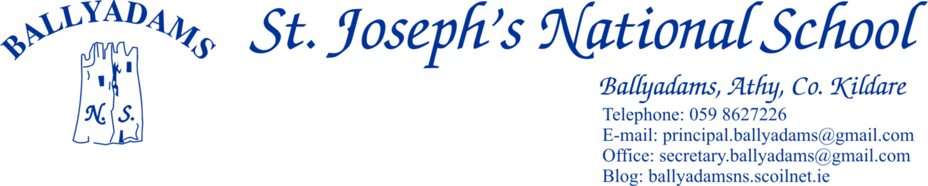

June 13th, 2018

***June Newsletter***

**Parents’ Council**

The final Parents’ Council meeting of the year took place yesterday evening. On behalf of the Board of Management, the staff and pupils, I’d like to sincerely thank the parent body in general and the Parents’ Council in particular for your tremendous efforts throughout the year. We are very fortunate to have such a dedicated and capable group working on behalf of the school.

**School Tours**

All our school tours take place next week. On Tuesday, 2nd, 3rd and 4th Class will visit Fort Lucan in Dublin. On Wednesday, 5th and 6th Class will travel to Baysports, Athlone, while on Thursday, Junior Infants, Senior Infants and 1st Class will visit Lullymore. You should have received a note for each tour outlining what’s required, departure/return time etc. Please contact the office if you didn’t receive the note.

I’ll remind you that the Aladdin online payment model is very popular with a number of parents and those who wish to register for online payments can contact Pam in the office for further details.

**First Holy Communion**

Congratulations to the children in 2nd Class who received their First Holy Communion on May 12th in Ballyadams Church. We thank Mr Mullooly, the parents and Fr. Dunne for helping to prepare the children for their big day. Well done to our brilliant choir also and thank you to Ms Walsh and Ms Holden for preparing them so well.

**Sports**

Hard luck to our boys hurling team who recently lost out after extra-time in the final. They improved greatly as the competition progressed and were very unlucky not to win on the day. Well done lads, we’re very proud of your efforts. Thank you to Ms Kirwan for coaching the camogie team this year. Again, the improvement from first game to last game was enormous. They finished their campaign with an excellent victory over The Heath.

Football coaching with Sean Dempsey and Laois GAA coach/player Colm Begley continues every Wednesday for boys and girls in 3rd – 6th Classes. Mr Mullooly is co-ordinating our annual 2nd, 3rd and 4th Class lunchtime football league at present. The standard of play has been excellent and the final is due to be played on Monday.

Our lunch-time basketball league is nearing completion also. The final is due to take place on Monday also. Thank you to Ms Walsh for organising.

We had five representatives from 4th, 5th and 6th Class represent the school at the Laois Track and Field Athletics Championships yesterday. Thank you to Liam Byrne for facilitating.

**Active Flag**

Last week, we received official confirmation that we have achieved Active School Status and we are soon to receive our Active Flag. This is the culmination of tremendous work on behalf of Ms Walsh and our super committee. They’ve worked so hard over the past 18 months or so and this recognition is thoroughly deserved. We hope to raise our flag on Monday next at 1pm. Laois footballer Colm Begley will perform the honours. Parents are welcome to attend and witness us raise our flag. Please read our Active School Newsletter attached.

**Let’s Go Blue**

Ballyadams N.S. will show our support for the Laois Senior Football team ahead of the Leinster Final by ‘going blue’ on Monday next, June 18th. Children are encouraged to wear Laois gear, or alternatively, anything blue in colour in order to show support for the Laois team. Colm Begley and possibly one other member of the Laois panel will be with us on Monday to raise our Active Flag.

**Textaparent App**

There are still a significant percentage of parents yet to sign up to the TextaParent app. We’d encourage you all to do so if you’ve either an Apple or Android device. The more parents who download the app, the greater the saving for the school. It takes less than a minute to do so and it’s completely free to download.

**End of Year Reports/Book Lists**

The end of year reports will be posted the week ending, Friday June 22nd. Unfortunately, due to new Data Protection regulations, our online administrative system will not allow us to email reports this year. In order for us to post the reports, we are asking each family to send in a stamped addressed envelope to the office before Monday June 18th. Alternatively, reports will have to be personally collected from the office before June 28th. Book lists for the 2018/2019 school year will be sent home before June 28th. They will also be available to download from the school website.

**Absences/Roll Call**

In the report cards, it will state the number of days absent throughout the year. In compliance with Circular 0028/2013, we must complete the roll within one hour of instruction time commencing. It also states that *‘a pupil will be marked either present or absent at the time of roll call and there will be no provision for adjusting the Roll Book (Leabhar Rolla) where a pupil subsequently does not complete the full school day or arrives after the roll call’.* Therefore, if your child is late coming to school as he/she had to visit the dentist, doctor etc. and has a note to explain why they’re late, we still cannot adjust the roll once it’s completed. However, at the end of year presentations, late days (with notes) will not be considered absences when handing out certificates of attendance.

**Church Car Park**

The Board of Management would like to remind parents and those collecting children at 2pm and 3pm to please be mindful of child safety. We have over 100 children exiting the building at 3pm and it is important that we are conscious of the potential dangers associated with children walking in front of, behind and at the side of parked and moving vehicles. Please also ensure that the pedestrian crossing is kept clear at all times.

**School Closures 2018/2019**

Reopening - Thursday August 30th

​October Mid-Term - October 29th to November 2nd

Christmas Holidays - Close December 21st and reopen January 7th

​February Mid-Term - February 18th to 22nd (full week)

​St. Patrick's Bank Holiday - March 18th

​Easter Holidays - Close on April 12th and reopen on April 29th

May Bank Holiday Monday

​***June Bank Holiday - Closed Monday and Tuesday June 3rd and 4th (please note change from original dates on the website)***

​Summer Holidays - Close on Friday June 28th

The school will close at 12:30pm on Thursday June 28th 2018 for the summer holidays. Buses will run as normal at that time.

Mr. T. Fitzgerald

Principal