****



Telephone: 059 8627226

E-mail: [principal.ballyadams@gmail.com](mailto:principal.ballyadams@gmail.com)

Office: [secretary.ballyadams@gmail.com](mailto:secretary.ballyadams@gmail.com)

Website: www.ballyadamsns.com

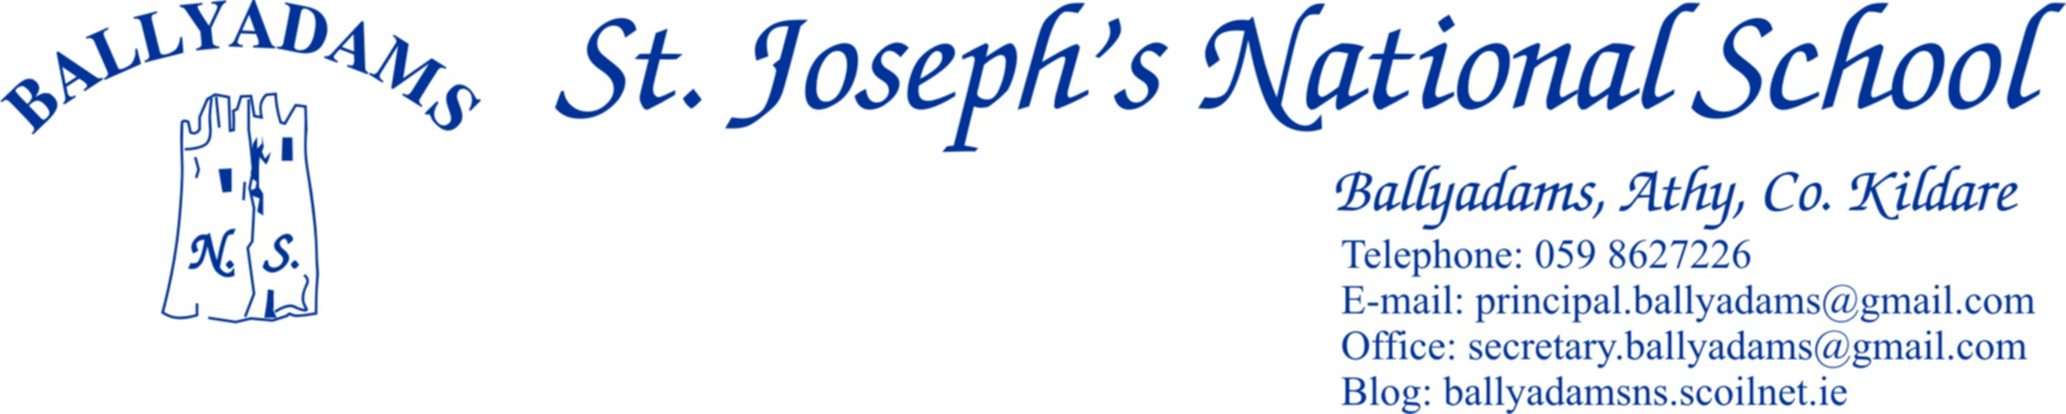

June 20th, 2019

***June Newsletter***

**Parents’ Council**

On behalf of the Board of Management, the staff and pupils, I would like to thank all parents and the Parents’ Council for your exceptional efforts throughout the year. The commitment of our Parents Council and generosity of our Parent body are a testament to the unique and special school spirit in Ballyadams.[Ní neart go cur le chéile.](http://www.daltai.com/proverbs/the-bigger-world/ni-neart-go-cur-le-cheile/" \t "_blank)

**School Tours**

All our classes embarked on school tours last week. On Wednesday 19th our Infant classes & 1st Class visited Clonfert Pet Farm. On Thursday our 2nd, 3rd and 4th Class visited Clara Lara Adventure Centre whilst 5th and 6th Class travelled to Baysports in Athlone.

**First Holy Communion**

First Communion took place May 18th in Ballyadams. Thank you to Ms Kirwan and Fr Dunne for preparing the children. Thank you to Ms Rowan for leading our school choir who sang beautifully on a very special day in the spiritual and school lives of our young boys and girls.

**6th Class Graduation and Infant Induction**

We celebrated the graduation of our 6th Class Friday 21st June. Thank you to all pupils in 6th Class for your superb contribution to Ballyadams N.S. We wish you well in secondary school. Junior Infant Induction Day took place June 6th. We welcomed siblings of current school pupils and also several new families to Ballyadams N.S. We wish all families and children beginning their primary school journey every blessing in the months and years to come.

**Slan agus beannacht Ms Kirwan & Mr McLoughlin**

It is with heavy hearts we bid farewell to Ms Kirwan. Ms Kirwan has been appointed as a permanent teacher in Derrylamogue N.S. Thank you for your dedication and incredible service to Ballyadams N.S. and best wishes in your future teaching career. Best wishes to Mr McLoughlin as he departs Ballyadams N.S and thank you for your contribution this year.

**Sports**

Ballyadams N.S teams reached the C.M.N.B Hurling & Camogie finals Wednesday May 29th in O’Moore Park. Both teams performed excellently. The boys were narrowly defeated vs Killenard and our Camogie team created history winning a sensational final vs Ballyfin. Sincere thanks to trainers Peter Barry, Ms Kirwan and Mr Mullooly for preparing the teams.

**Zeeko Internet Safety Day** tookplace Thursday 9th May. Facilitators from Zeeko conducted safety seminars with students and teachers. A parent information talk and presentation took place in the school that evening. Thanks to the Parents Council for supporting the initiative. The pupil led approach to promoting best values and practice with regard to internet safety was well received in the school and will enhance our internet safety and anti – bullying prevention strategies in the future.

**Friendship Week**

Friendship Week took place in May. Cooperative activities and friendship building games were organized throughout the week. We welcomed special guests during the week. Former Principal Ms O’Connor paid a lovely visit to each of the classes. Horticulturalist Ms Maeve Flynn visited the school. Maeve Flynn spoke to each class about the natural beauty and growth in our school environment and assisted each class in planting a sapling Silver Birch tree in the school grounds. Thank you to our Friendship Committee representing all classes and Playground leaders who promoted extra acts of kindness during the week.

**Active School Week**

We celebrated Active Schools Week in Ballyadams June 10th – 14th. Well done to the boys and girls for making the week a success. We walked as we talked each morning around our school pitch, cycled our bikes and participated in a range of healthy, sporting activities all week. Special word of thanks to our fabulous Active School Student Committee for your enthusiasm and organisation throughout Active Week.

**Book Lists**

Book lists for the 2019/2020 school year will be sent home before June 28th. Booklists will also be accessible on the school website.

**Church Car Park**

The Board of Management would like to remind parents and those collecting children at 2pm and 3pm to please be mindful of child safety. **Please park in the church Car Park when collecting children.** This measure is to safeguard against the dangers associated with children walking in front of, behind and at the side of parked and moving vehicles. Thank you for your cooperation.

**School Closures 2019/20**

Reopening - Thursday August the 29th.

​October Mid-Term – Monday 28th October – 1st November inclusive.

Christmas Holidays – Friday 20th December – re- open Monday 6th January

​February Mid-Term – February Monday 17th – Friday 21st inclusive.

​Monday March 16th

St. Patrick's Bank Holiday - March 17th

​Easter Holidays - Friday 3rd April – re – open Monday 20th April

​Summer Holidays - Close on Friday June 28th

The school will close at 12.30pm on Friday June 26th 2019 for the summer holidays.

I would like to thank the school community for your efforts throughout the school year. I wish all members of our school community a peaceful and relaxing Summer break. We look forward to another exciting and rewarding school year in 2019 / 20.

Is mise le meas,

R.Stapleton

Principal