Name Scavenger Hunt 27th April-1st May
Can you work out who each picture belongs to?
- 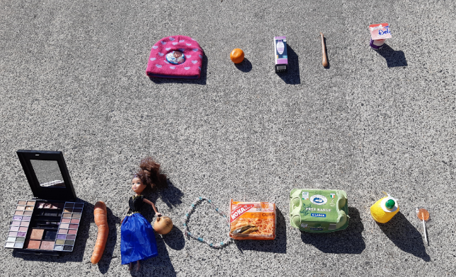
Guess:___________________________________
Clue: This is a girl in Senior Infants who included her last name too
- 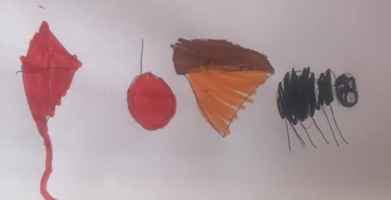
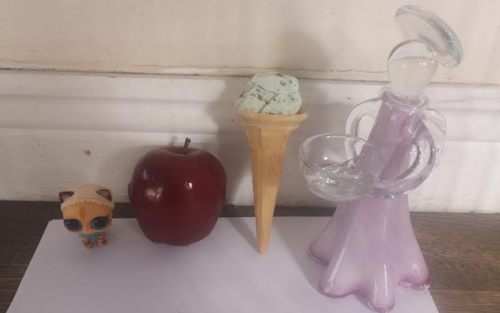
Guess: ____________________________________
Clue: This girl in Juniors took a picture and drew objects too!

- 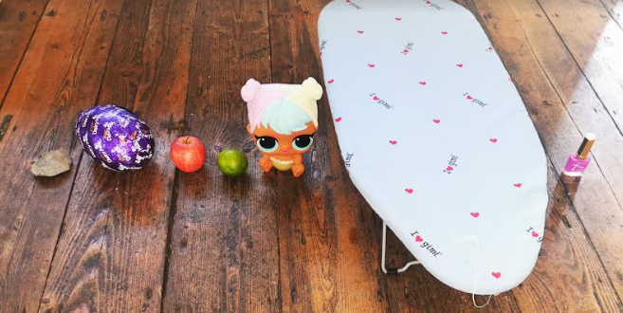
Guess: _______________________________
Clue: This is a girl in Junior Infants who has 7 letters in her name.

- 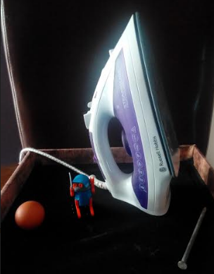
Guess: ____________________________
Clue: This is a girl in Junior Infants who has 4 letters in her name.

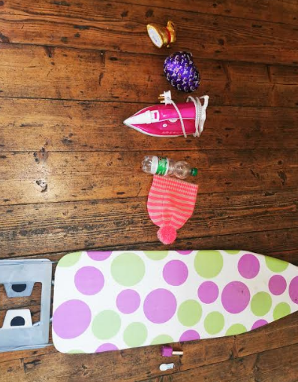

Guess: __________________________
Clue: This is a girl in Junior Infants and she has 8 letters in her name.

- 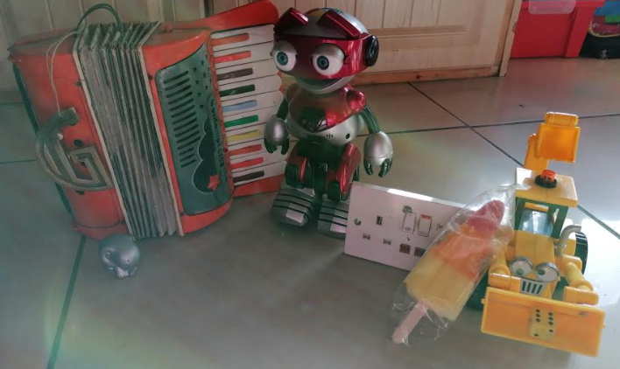
Guess: __________________________
Clue: This boy in Seniors has 7 letters in his name. Think carefully about what letter we learned that has a light switch in the action!

- 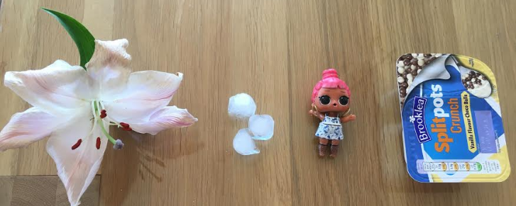
Guess: _____________________________
Clue: This girl has given you an extra clue!

- 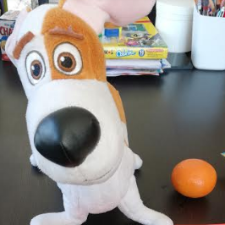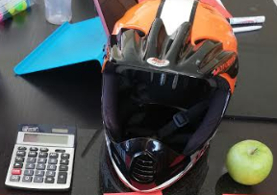
Guess: ______________________________
Clue: This is a boy in Seniors who has 7 letters in his name.

- 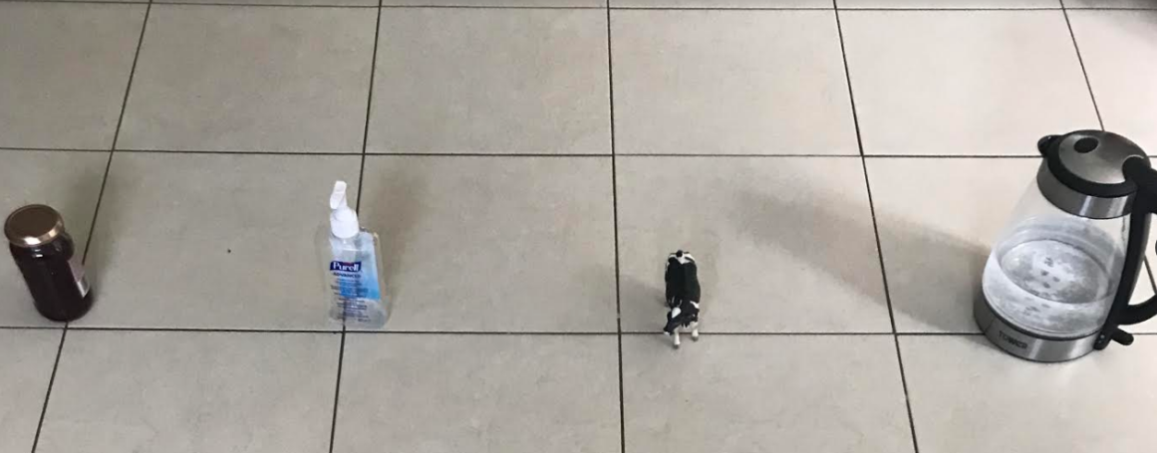
Guess: ______________________________
Clue: This boy in Seniors has 4 letters in his name.

- 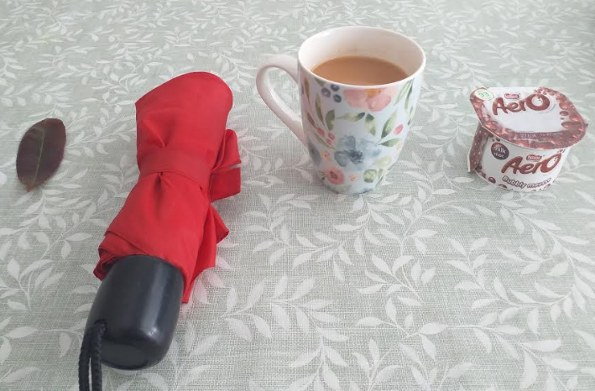
Guess: _____________________________
Clue: This is a Senior Infants girl with 4 letters in her name.

- 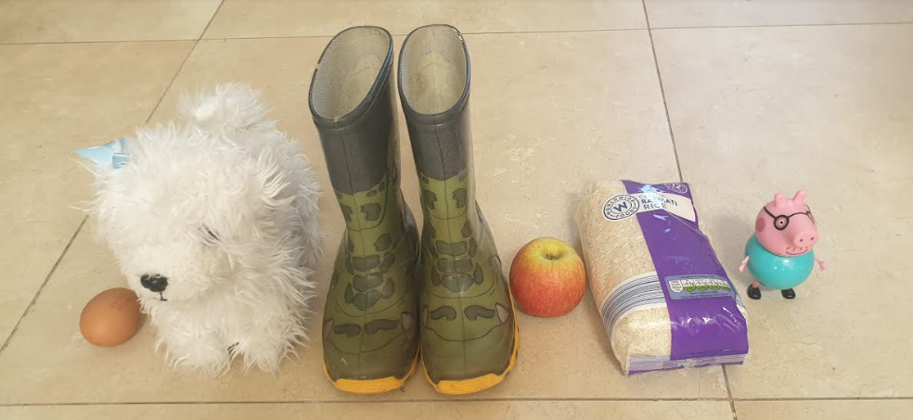
Guess: ______________________
Clue: This boy has 6 letters in his name

