



Telephone: 059 8627226

E-mail: [principal.ballyadams@gmail.com](mailto:principal.ballyadams@gmail.com)

Office: [secretary.ballyadams@gmail.com](mailto:secretary.ballyadams@gmail.com)

Website: www.ballyadamsns.com

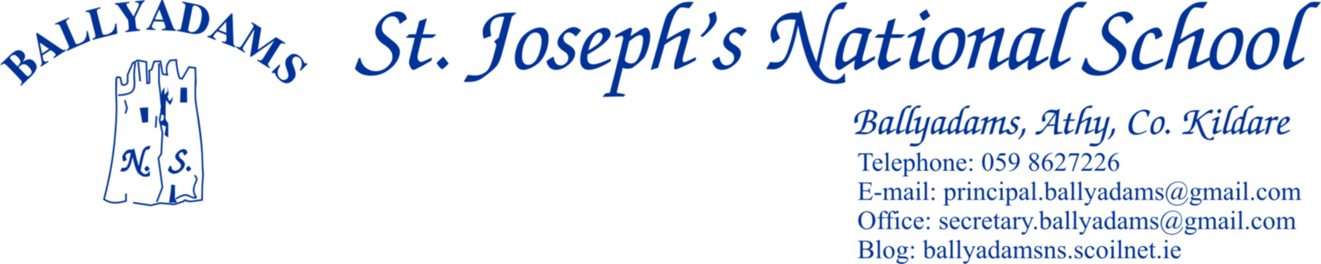

November 28th, 2016

***Newsletter***

**Parking and Morning Supervision**

Once again, I’ll remind ***some*** parents that the car park at the school is for **staff parking only** and should not be used for parking, dropping off or collecting children. **Not only does this apply at 3pm, but it also applies at 9:20am and 2pm.** All parents are asked to use the car park adjacent to the church. I’ll also remind you that morning supervision does not begin until **9:10am** each morning. Therefore, your child should not be on the school premises before then.

**Christmas Raffle and Cake Sale**

The Parents’ Council have been very busy in recent weeks preparing for our annual Christmas Raffle and Cake Sale. The Raffle and Cake Sale will take place on **Sunday December 4th** in the school hall directly after 11 o’clock mass. We hope this year’s event will be as successful as previous years and we’d really appreciate your support for the Cake Sale by baking a cake, tart, cupcakes etc. for someone to enjoy after their Sunday lunch. If you’re unable to do some baking, please come along and buy some of the lovely home baking which will be on sale. All baked items can be left into the school Saturday night December 3rd between 5:30pm and 6:30pm or from 10am on Sunday morning.

We’ve had a number of tickets returned already for the Christmas Raffle. If anyone would like to buy or sell some extra tickets, they are available from the school office. Please ensure that **tickets are returned to the school by** **Thursday December 1st**. All families who return their tickets by 1pm Thursday will be included in a special raffle for a Christmas tree and children’s hamper. This will be our major fundraiser for the current school year.

On behalf of the school and the Board of Management, I’d like to thank sincerely all those parents who have sold tickets, donated items to make up hampers, given up their free time to sell tickets at some of the local supermarkets, secured raffle prizes and baked cakes.

**Calendars**

The 2017 school calendars will be sent to print on Wednesday, so please place your order with full payment before then to avoid disappointment. There has been an excellent response so far and I’d like to thank all those who’ve already placed their order. A sneak preview of some of the photos on the calendar are available on the school website [www.ballyadamsns.com](http://www.ballyadamsns.com) and the school twitter page. Sincere thanks once more to Kathleen Crosby doing such a great job in putting the calendar together.

**Christmas Performance**

There is no formal Christmas Show this year. However, on the afternoon of Tuesday December 20th, each class will put on a short performance (Christmas carols, songs, poems etc.) Kim Melia from Music Generation Laois will also conduct a performance with the classes receiving recorder lessons. Parents, grandparents and family members are welcome to attend. We hope to start at approximately 1pm. We will confirm for definite closer to the time.

**St. Vincent de Paul Fun Day**

Our annual St. Vincent de Paul ‘Fun Day’ will take place on Wednesday, December 21st. 6th Class will once again take charge on the day, as they organise and oversee various fun activities and games. As we all know, St. Vincent de Paul do outstanding work in our local communities, and this fundraiser presents the children with an opportunity to contribute to their tremendous work, especially at this time of the year when families and individuals are most in need of support. The children are asked to bring in assortments of 10c and 20c coins on the day.

**First Holy Communion - Enrolment Mass**

The Enrolment Mass for Mr. Mullooly’s 2nd Class pupils takes place this coming Sunday, December 4th in Ballyadams Church at 11am. The Christmas Raffle and Cake Sale will take place immediately afterwards in the school hall.

**Parent/Teacher Meetings**

Parent/teacher meetings will take place this Wednesday November 30th and Thursday December 1st. Please contact the school office if you are unable to attend.

**Primary Science Fair**

Well done to Mrs. Murray’s class who’ve been accepted to display their project at the Primary Science Fair on January 19th in Mary Immaculate College, Limerick.

**Parental In-Class Support**

In recent weeks, parents have been helping with literacy station teaching in 1st and 2nd Class. We hope to continue this initiate at various stages throughout the school year in different classes. If you are in a position to help out, please contact the school to put your name forward. There is no obligation on anyone to commit themselves on a long term basis. It might be one day a month or fortnight that suits. Pam will look after the rota in the office and you can let her know what days suit. We’d like to extend the invitation to other people in the community who might be interested in getting involved, so please spread the word. I’d like to thank those parents who’ve volunteered already. Your support is greatly appreciated.

**Boys Hurling**

There is hurling coaching for the boys in 4th, 5th and 6th Classes every Monday lunch time in the school hall. Please bring a hurl and helmet to school on those days. If anyone is finding it difficult to source equipment, please let me know as we have a limited supply of hurls and helmets in the school.

**School Website**

I’ll remind you that the parents’ section of our school website includes links to useful educational websites, previous newsletters, school calendar and a Parents’ Council page. You can visit us out at [www.ballyadamsns.com](http://www.ballyadamsns.com)

**Christmas Holidays**

We will close on **Thursday, December 22nd at 12:30pm** when we break for the Christmas holidays. The school will reopen on **Monday, January 9th.**

As this is the last newsletter of the year, I’d like to extend a sincere thank you to all our parents for your wonderful support and assistance throughout the year. I wish you all a very happy Christmas and a wonderful 2017.

Mr. T. Fitzgerald

Principal