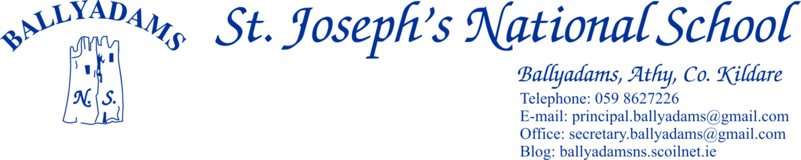
September 5th, 2016

Welcome to the 2016/2017 school year, one which we hope will be enjoyable, busy and productive for all. We would especially like to welcome all our new pupils in Ms. Walsh’s Junior Infants and congratulate them all for settling in so well to school.

Opening Times and Morning Supervision
I’ll remind parents that morning supervision does not begin until 9:10am each morning. Therefore, your child should not be on the school premises before then.
The new Junior Infants will continue to finish at 12pm this week, but from next Monday, September 12th onwards, they will finish at the normal time of 2pm.

P.E. Times
P.E. times for your child will be sent home by their class teacher this week. Tracksuits may be worn on these days. On all other days your child should be in their school uniform. Children who wish to play football/games on the playing field at lunch time must bring a spare tracksuit bottoms/shorts and football boots/old runners to school.

Marking Clothes
All tops, jumpers and coats should be clearly marked with your child’s name.

Parents Council
The Parent’s Council A.G.M. will take place on Monday September 19th at 8:30pm in the school. Our Parent’s Council are a very active and welcoming group and we would encourage you to attend on the night.

Parking
The car park at the school is for staff parking only and should not be used for parking, dropping off or collecting children. Not only does this apply at 3pm, but it also applies at 9:20am and 2pm. All parents are asked to use the car park adjacent to the church. Please bring this notice to the attention of child minders and anyone who might drop or collect your child from school.

Cumann na mBunscoil Football
Our boys and girls will begin their respective football competitions this week. We wish all our players the very best of luck. Players are reminded to wear gum shields at all times.
Best wishes to last year’s 6th Class pupil Oisín Hooney, who was selected, through Cumann na mBunscol, to represent Laois at half time in the upcoming All Ireland Football Final. It is a great honour for Oisín, his family, club and school. We wish him all the best on the day and hope he thoroughly enjoys the occasion.

Garda Vetting
As stated in a letter to you last March, we have been informed by our insurance company and our patron body, that all parents/grandparents/older siblings who generously give their time freely to drive pupils to and from Cumann na mBunscol games, choir practice etc. must now be Garda vetted through the school. At that stage, a number of parents did get vetted through us and we are thankful to them. As the Cumann na mBunscol season is about to begin again, I’ll remind you that only those vetted through the school can carry children other than their own to and from matches.
The goodwill and generosity of parents contributes greatly to the smooth running of the school and we thank you once more for your support. If you are willing to be vetted for school activities, there are forms available from Pam in the office.

Lunches
I’ll remind you of our Healthy Eating policy in the school. Also, please encourage your child to bring home any crusts etc. that they have not eaten. Sometimes you may think that they are eating their lovely lunch when in fact they have thrown it in the bin.

Invitations
Birthdays are great occasions and the cause of justifiable excitement for every child. Organising your child’s birthday party is great fun but with classes of 25-30 it would be unreasonable to expect that any family would invite every member of the class to a celebration. Invitations delivered at school can unintentionally cause great hurt when one or more are not included so I would ask that no invitations are issued by children through the school.

New School Website
We created a new school website over the summer. It is only in its infant stage so we hope to grow and develop the website further in the coming months. You can check us out at www.ballyadamsns.com

E-Payments
We received a very positive response to the introduction of our e-payment system last year and a large number of parents have already availed of the service. If you have any queries or wish to seek further information/clarification, please contact Pam in the office.

Staff In-Service
The school will close at 12:15 pm on Wednesday September 28th to allow for staff in-service on the new Religious Education programme, Grow in Love. Buses will run as normal at this time.

Reminder of School Closures 2016/2017
October 31st – November 4th - Halloween Midterm Break
Closing December 22nd and reopening January 9th – Christmas Holidays
February 23rd and 24th – Midterm Break
Closing April 7th and reopening April 27th – Easter Holidays
Closed Friday June 2nd and Tuesday June 6th with Bank Holiday
The school will close for the summer holidays on June 28th 2017.

School Contact
The school phone number is 059 8627226. Should you wish to email the principal please use principal.ballyadams@gmail.com and should you wish to contact the office please use secretary.ballyadams@gmail.com. You can contact Pam in the office between 9.30a.m and 1pm each day.
If the need arises to contact me or if you would like to make an appointment to see me, I ask you to make an appointment through Pam in the office. I am also teaching 6th Class this year, so I will be unavailable to meet parents between 9:10am and 3pm.

We look forward to another successful and productive school year.

Mr. T. Fitzgerald
Principal

