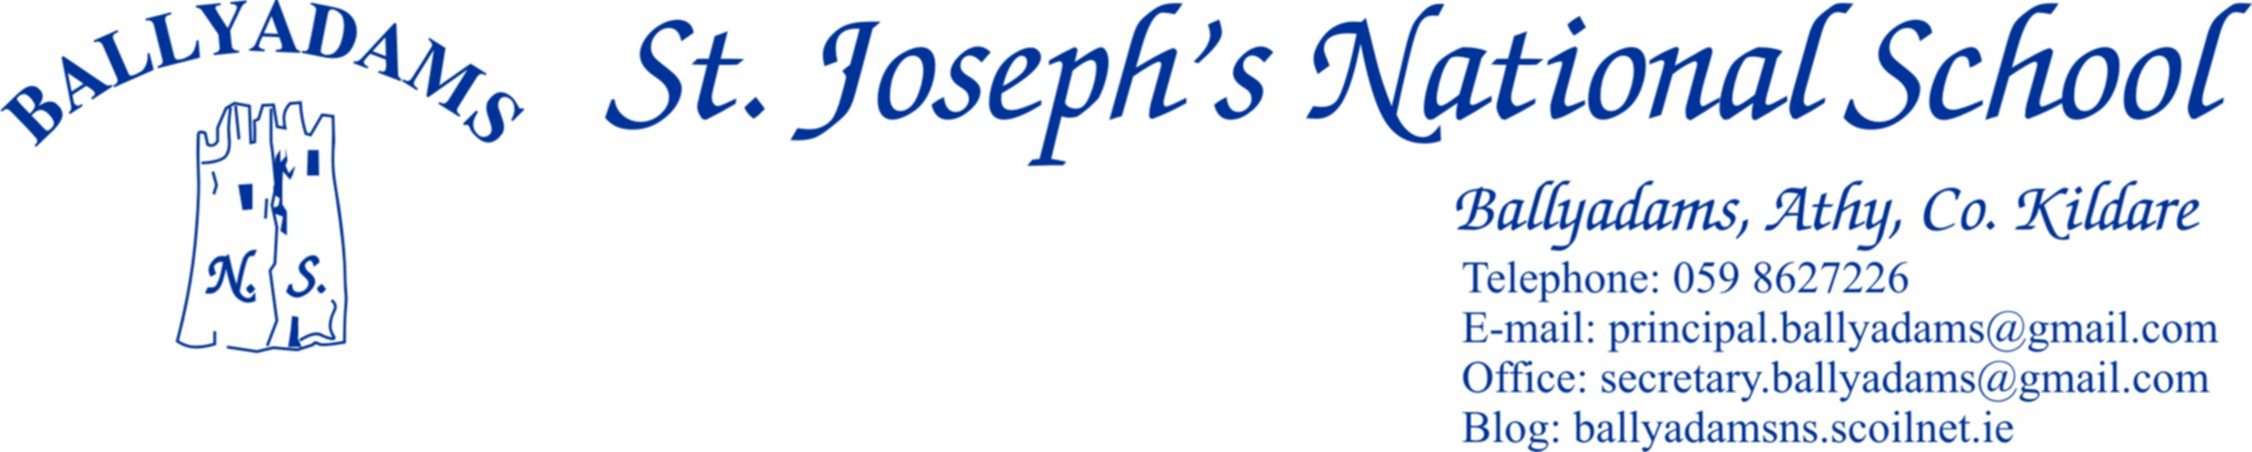





Telephone: 059 8627226

E-mail: [principal.ballyadams@gmail.com](mailto:principal.ballyadams@gmail.com)

Office: [secretary.ballyadams@gmail.com](mailto:secretary.ballyadams@gmail.com)

Website: ballyadamsns.com

***September Newsletter***

Welcome to the 2017/2018 school year, one which we hope will be enjoyable, busy and productive for all. We would especially like to welcome all our new pupils in Ms. Walsh’s Junior Infants and congratulate them all for settling in so well to school.

**Opening Times and Morning Supervision**

I’ll remind parents that morning supervision does not begin until **9:10am** each morning. Therefore, your child should not be on the school premises before then.

The Junior Infants will continue to finish at 12pm this week, but from next Monday, September 11th onwards, they will finish at the normal time of 2pm.

**P.E. Times**

P.E. times for your child will be sent home by their class teacher this week. Tracksuits may be worn on these days. On **all** other days your child should be in their school uniform. Children who wish to play football/games on the playing field at lunch time must bring a spare tracksuit bottoms/shorts and football boots/old runners to school.

**Marking Clothes**

All tops, jumpers and coats should be clearly marked with your child’s name. There are a number of coats, jumpers and trousers left unclaimed in the school. You are welcome to call and claim items if you please.

**Parents’ Council**

The Parents’ Council A.G.M. will take place in the coming weeks and you will receive notification by text. Our Parents’ Council are a very active and welcoming group and we would encourage you to attend on the night.

**Parking**

The car park at the school is for **staff parking only** and should not be used for parking, dropping off or collecting children. **Not only does this apply at 3pm, but it also applies at 9:20am and 2pm.** All parents are asked to use the car park adjacent to the church. **Please bring this notice to the attention of child minders and anyone who might drop or collect your child from school.**

**Cumann na mBunscoil Football**

Our boys and girls will begin their respective football competitions next week. We wish all our players the very best of luck. Players are reminded to wear gum shields at all times.

**Garda Vetting**

As has been the case for the past year, all parents/grandparents/older siblings who generously give their time freely to drive pupils to and from Cumann na mBunscol games and other school events must now be Garda vetted through the school. I’ll remind you that only those vetted through the school can carry children other than their own to and from matches. The goodwill and generosity of parents contributes greatly to the smooth running of the school and we thank you once more for your support. If you haven’t already done so but are willing to be vetted for school activities, there are forms available from Pam in the office.

**Parents/Adults Wanted**

We have begun literacy station teaching in 1st and 2nd Class. However we require assistance from any interested adults in order to maximise the time allocated. These can be parents, grandparents or members of the community. Volunteers don’t have to have an immediate connection to any of the pupils in 1st and 2nd class. It takes place Monday to Thursday from 2:10pm to 3pm and will run over the coming weeks. Please give Pam in the office a call if you are willing to help out on occasion.

**Lunches**

I’ll remind you of our Healthy Eating policy in the school. Also, please encourage your child to bring home any crusts etc. that they have not eaten. Sometimes you may think that they are eating their lovely lunch when in fact they have thrown it in the bin. The HSE have published a new ‘Healthy Food for Life Pack’ for use in schools and at home. The pack contains the new Healthy Eating Guidelines and the revised Food Pyramid. A link to the resources can be found on our school website [www.ballyadamsns.com](http://www.ballyadamsns.com).

**Invitations**

Birthdays are great occasions and the cause of justifiable excitement for every child. Organising your child’s birthday party is great fun but with classes of 25-30 it would be unreasonable to expect that any family would invite every member of the class to a celebration. Invitations delivered at school can unintentionally cause great hurt when one or more are not included so I would ask that no invitations are issued by children through the school.

**Requisites/E-Payments**

Most parents have now paid their requisites and book rental fees in full. We thank you for your co-operation. Remember that 24 Hour accident insurance cover from Allianz is provided within that payment. The majority of parents are now using our e-payment facility and the feedback from it has been very positive. If you have any queries or wish to seek further information/clarification, please contact Pam in the office.

**Welcome back Ms. Kirwan**

We are delighted to welcome Ms. Kirwan back to our school this year. She is teaching 4th and 5th Class.

**Reminder of School Closures 2017/2018**

**Halloween Midterm:** Mon Oct 30th – Friday Nov 3rd

**Christmas:** Close on Friday Dec 22nd and reopen on Mon Jan 8th

**February Midterm**: Feb 15th and 16th

**Close for St. Patrick's Day Bank Holiday** - Monday March 19th

**Easter:** Close March 23rd and reopen April 9th

**May Bank Holiday:** Closed Friday May 4th and Tuesday May 8th

**June Bank Holiday**: Closed Friday June 1st and Tuesday June 5th

**Close for the summer holidays on Thursday June 28th 2018**

**School Contact**

The school contact details are printed at the top of the page. You can contact Pam in the office between 9.30a.m and 1pm each day. If the need arises to contact me, or if you would like to make an appointment to see me, I ask you to make an appointment through Pam in the office. I am also teaching 5th and 6th Class this year, so I will be unavailable to meet parents between 9:10am and 3pm.

Mr. T. Fitzgerald

Principal